Today we will learn...

1. What is Extent Report

2. How to add Extent Reports in Selenium

helpful tips

What is Extent Report

HTML Reporting library

ExtentReports is an open-source reporting API for Java and .NET. It creates an interactive HTML report of your test session.

ExtentReports also has a commercial version (Pro)

How to implement ExtentReports in Selenium Java

Step 1 :

Add ExentReports libraries in project

You can add jars or maven dependency

Step 2 :

Create references of ExtentReport func

Step 3 :

Use ExtentReport functions

log, info, pass, fail etc

Step 4 :

Run and Validate

REFERENCES

http://extentreports.com/docs/version...

PLAYLISTS



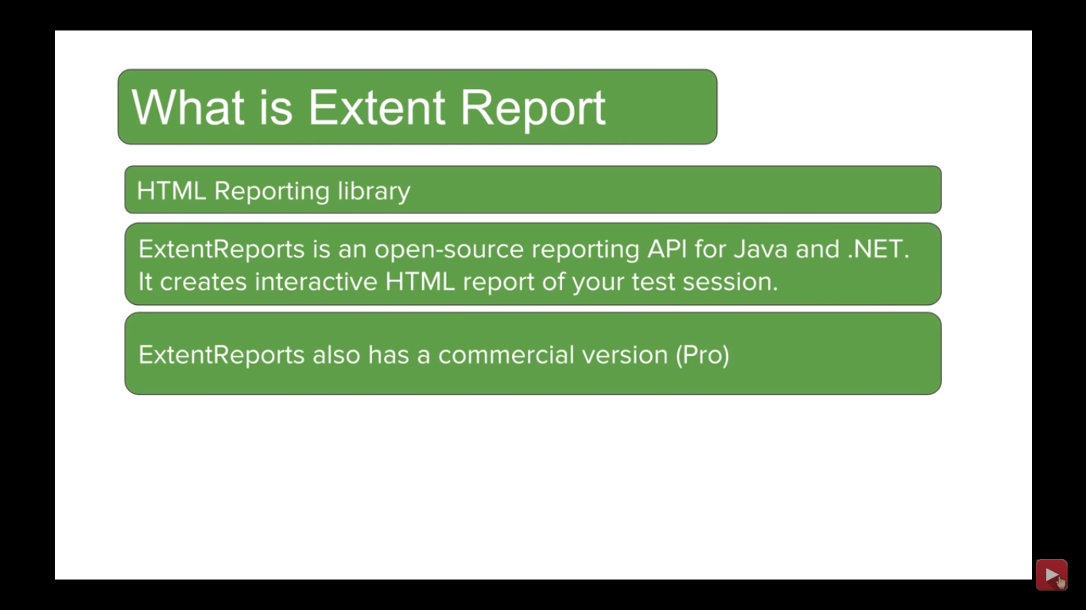

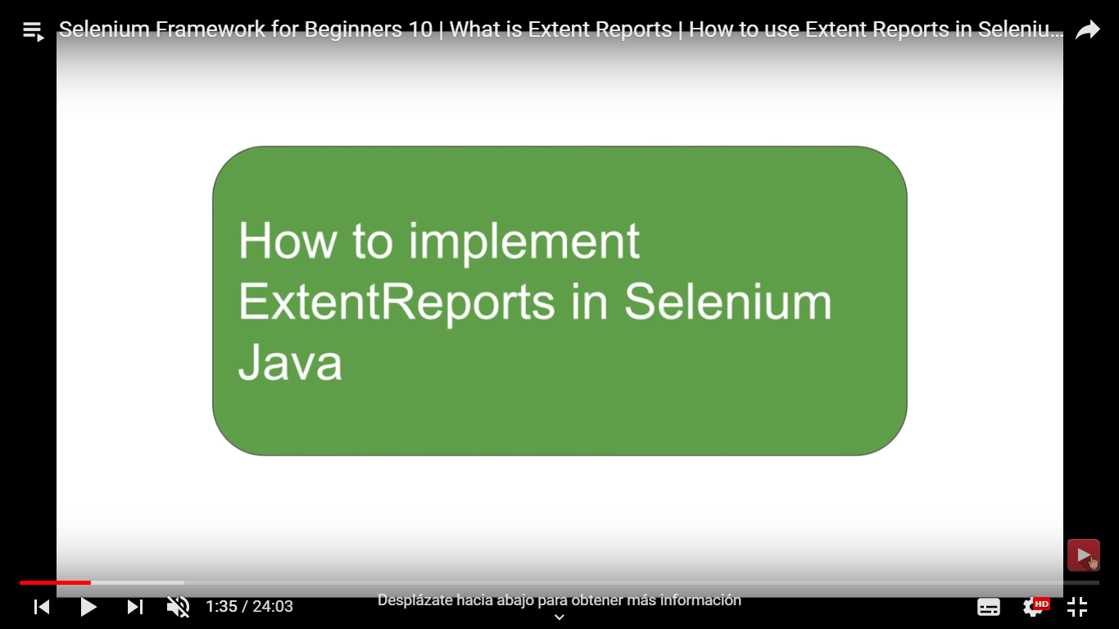

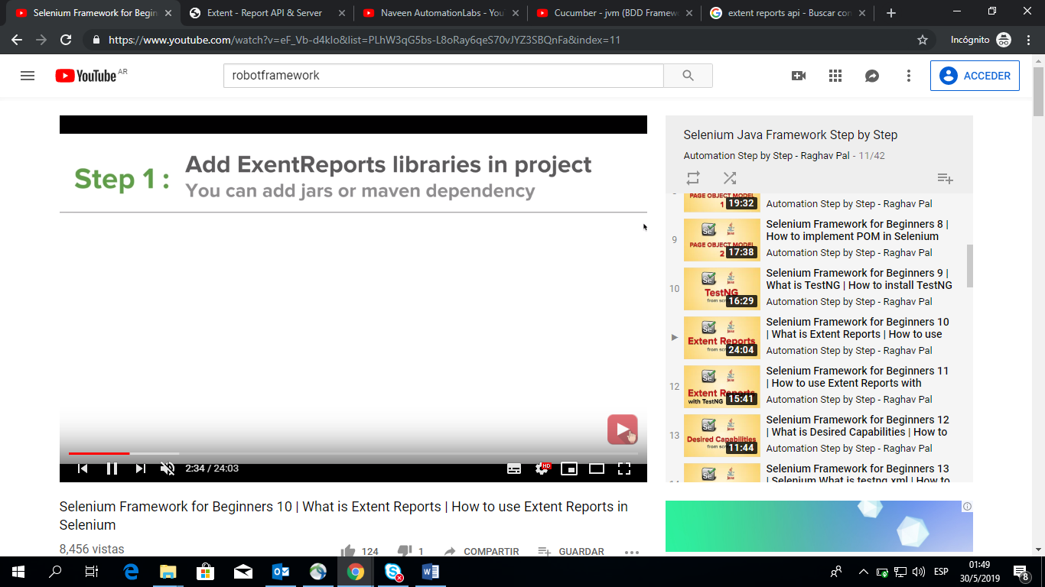

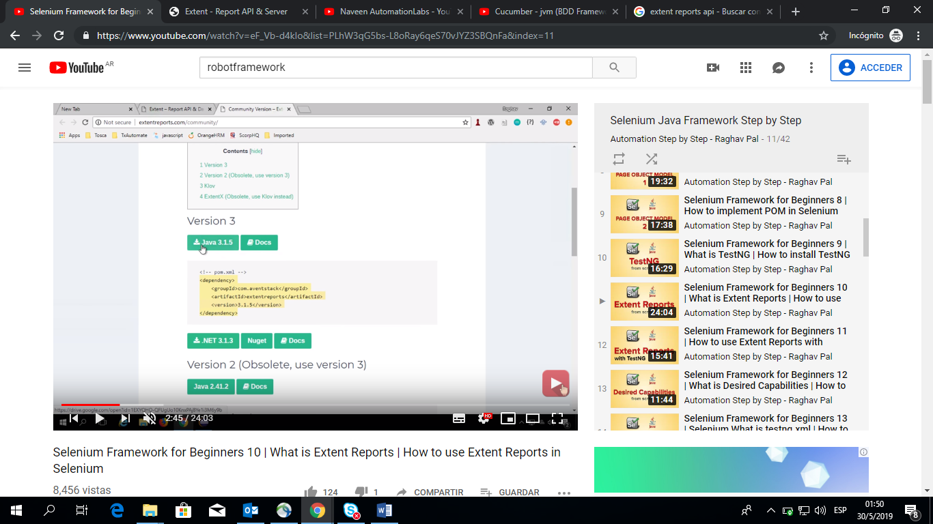

Buscar en maven repository- extent reports for selenium

Pagina extentReports : <http://extentreports.com/docs/versions/3/java/#basic-example>

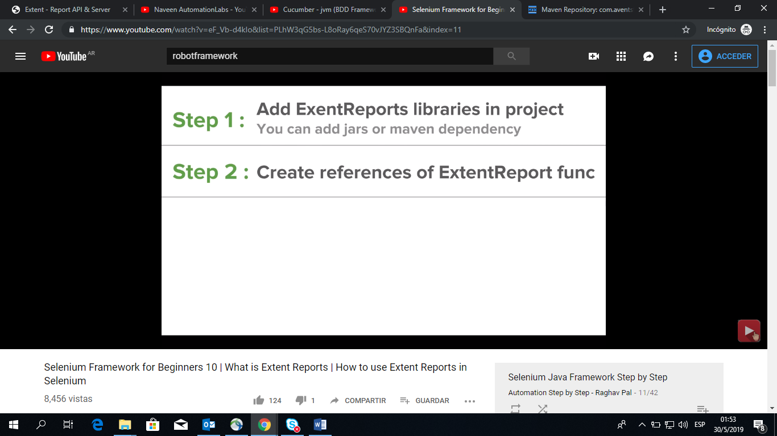

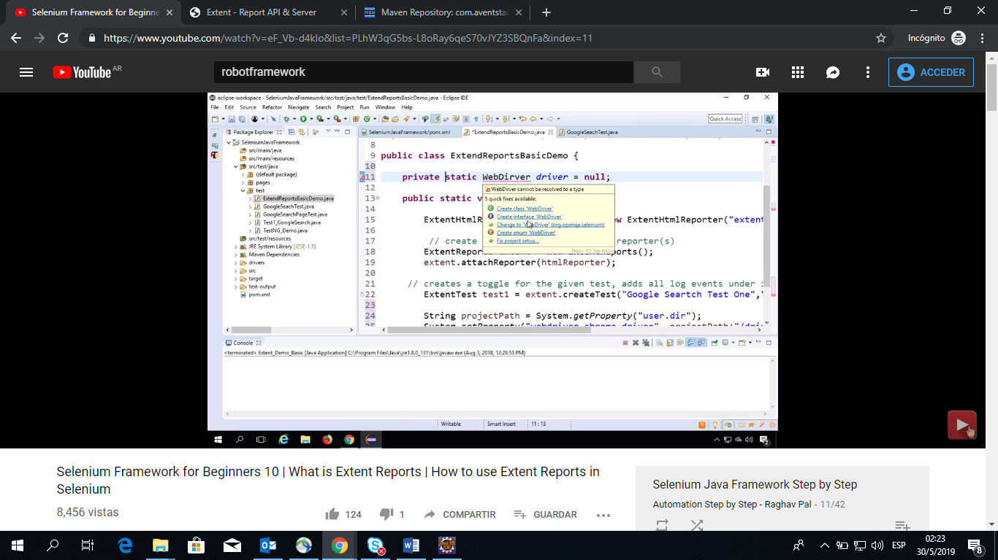

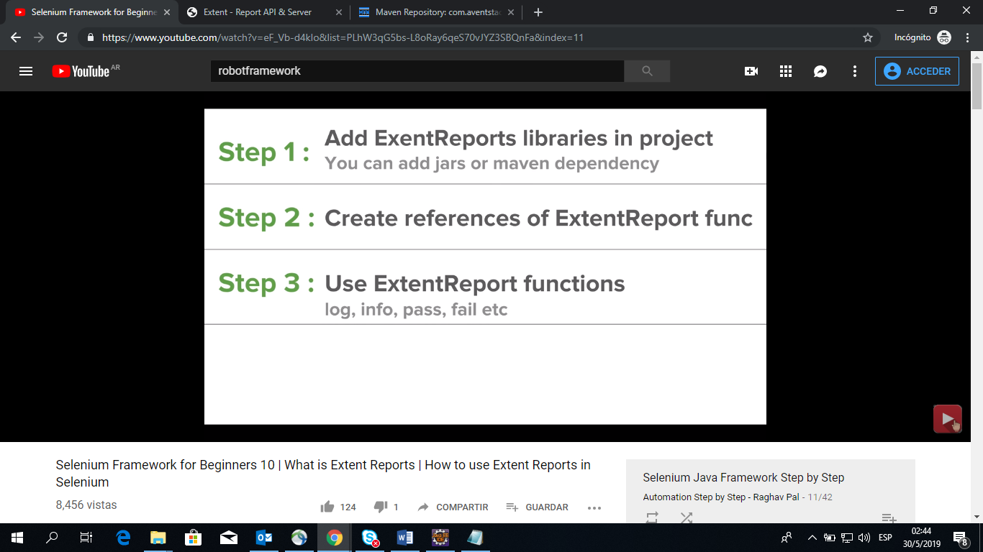

# Error: no puedo crear la carpeta del output donde me muestra los reportes

Fijarse como guardarlo en una carpeta